**Website Design Document for a Mass Effect Fan Site**

By Seán Burke GD1b

**Concept**

My website is going to be designed and based on the video game series Mass Effect. Mass effect is a Sci Fi, Roleplaying / third person shooter hybrid and is one of the most well-known and successful game franchises of all time. There are three different games in the trilogy I will build my website around.

* Mass Effect 1
* Mass Effect 2
* Mass Effect 3

With the series launching in 2007 and concluding in 2012, there is an endless amount of content and information that has been passed down through the years that I can add to my website and make multiple pages out of.

**Target Audience**

* Target user would vary from 16-40
* Older users who played the games when they first released 16 years ago and younger users who recently discovered the series.
* Players who want to learn about the game’s development.
* Majority of the website content will be for experienced Mass Effect players.
* Ideal user would have 35+ hours of gameplay experience having finished all the games.
* Players who haven’t finished the game yet should still be able to enjoy the website.
* New players who can get a spoiler free glimpse into what Mass Effect is.

With Mass Effect first releasing in 2007 and getting a worldwide following like other Sci-Fi universes such as Halo and Star Wars. It has a very broad audience. The Mass Effect Legendary edition was released in 2021 remastering the trilogy and introducing it to a whole new generation. This means there will be many users new to the series, aged 16 to 21. They will be the primary target audience for my website as they will be to users who will learn the most information exploring my website and get the most out of all the pages.

There will also be another group I would expect to use my website frequently, this being young adults aged 22 to 29. They will have played the games in the past but are either replaying the games again or are just looking to find more information on the games they enjoyed in the past. Another group who would enjoy my website would be users aged 30-40. They will most likely have played the games when they first released 16 years ago and will know almost everything there is about the games already. They may be exploring the website just for nostalgia or just to check out something Mass Effect related as we haven’t seen much new content since 2013.

Mass Effect fans haven’t had any new content since 2014 so they are desperate for any forms of new information on the old games or potential new upcoming games. This works in my favour as I should be able to attract a good number of Mass Effect fans if the content in my website is appealing enough. I would not want to spoil the game for any newcomers to the trilogy, so if I had more time to develop the site, I would have user first fill out a questionnaire about how much of the game they have played and hide any spoiler content based on their answers.

**Website Structure and Main Elements**

The website will feature a lot of background information about the Mass Effect trilogy, including:

**Pages finished for CA2.**

* Page 1 – An attractive landing pages.
* Page 2 – Voice Actors in the games page
* Page 3 – Games page about Mass Effect 1
* Page 4 – Area with all the cinematic trailers for each game
* Page 5 – Shop where people can purchase Mass Effect merchandise.

**Additional Elements.**

* An introduction for people new to the trilogy.
* A space and sci fi themed colour scheme.
* Embedded videos, gifs, and images
* Organized content in blocks and sections
* A footer on each page

**Additional Concept Ideas**

* Who produced the music.
* Extra info about the games universe (Races, History, Characters, and Worlds, etc.)
* Information about each of the games.
* Updates on any recent news.
* A section for all the games trailers.
* Information about extra content such as mods, fan films and books.

Each of the pages I am doing is a template, that if given more time can be switched up and edited to produce enough unique pages to flesh out an entire website. I have designed them all in sections with space for images, videos, gifs, headings, and paragraphs of text. For example, if I am to make a page for Mass Effect 2, I would be able to just edit and swap around the elements of the Mass Effect 1 page to get what I want.

Section of the Voice Actor Page


II want my website to be a place where a new or old Mass Effect fan can come and find all they need. The games pages will include a quick overview of the game along with some images and videos to make the page look nice. They will have a unique layout separate to the rest of the site. For the pages about each of the voice actors I will just be talking about the people who played the role and what other roles they have done in the past.

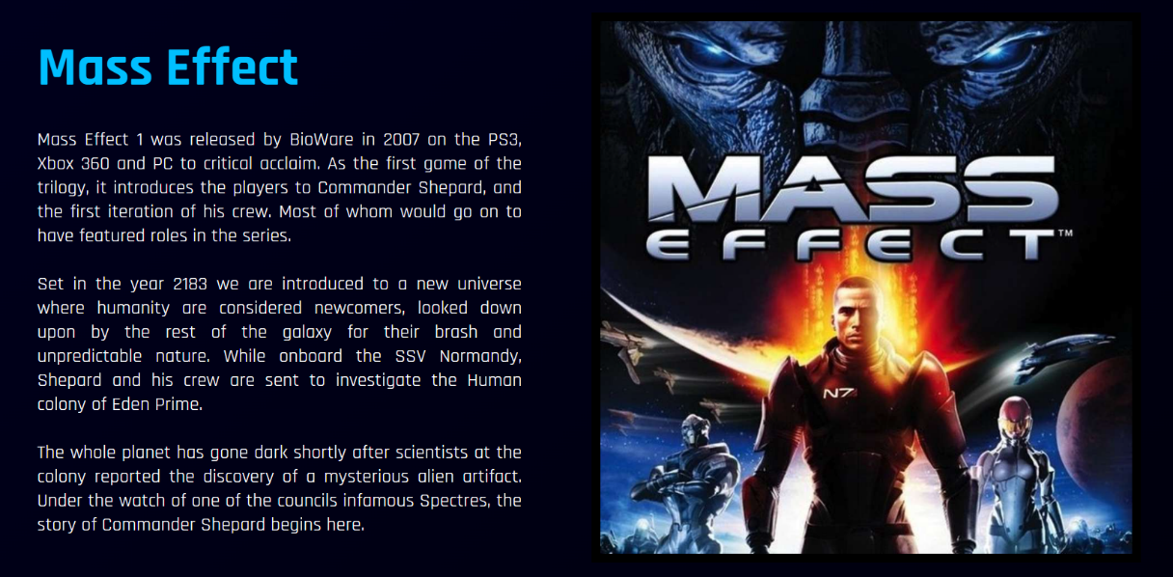

**Thematic Styling and Visual Elements**

I want my website to really grab the feeling of Mass Effect when you open it and browse through its contents. I also want visual elements that respond to the user throughout the website. This will give the pages a better feeling and help keep the user engaged as a static website can look bland and be very boring to browse. Below are some of the choices I wanted to implement in my design to achieve this.

* Sleek and Modern design.
* 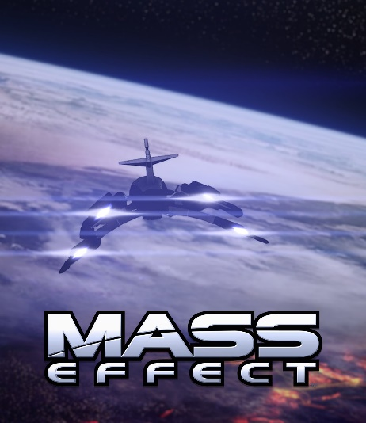Incorporate videos into the webpage.
* Iconic background shot for the landing page.
* Animations on hover for elements of the website.
* Sleek looking font with different weights.
* Bright fonts on dark backgrounds.
* Relevant colours to the game and setting.
* Edited photos to blend in with the layout.
* Easy to read and styled Navigation Bar.
* Stylised buttons to navigate the website.
* Give everything space and avoid big clumps.
* Consistent navigation bar that can take you anywhere.
* White on Black with red animations
* Blue and red headings with white text in the text heavy sections.

All the images and videos are taken directly from the game itself, so I credit the websites content in the footer as being copyrighted by the game developers themselves EA and BioWare.

**Usability and Accessibility**

While my website is aimed towards more experienced off-board players I also want newer players to be able to experience it if they come across. All the elements of my website are designed to be easy to read and understand. The colours are simplistic and easy to read, while everything also has enough space to breath, so nothing feels cluttered.

* Instruction for the user to scroll down and start engaging with the website.
* Basic information about what the website is and what Mass Effect is.
* At the bottom of the page, I want to include an interactive section that gets users started exploring the trilogy.
* A games page that is spoiler free in case a user has not played the game yet and have just come across the website.
* Hide the characters and other content that the player hasn’t seen yet based on what games they have played in the questionnaire.
* In the trailers page you can only view the videos you want by having the option to hide the section for each game.

**User Interaction and Functionality**

Now that my website includes JavaScript, I have been able to increase the user interaction and functionality in most of the pages.

* A screenshot of a video game

  Description automatically generatedButtons on pages that allow the user to show and hide various elements to suit what they want to see.
* An interactive shop that allows players to choose what they want to buy and how much they want to buy.
* A slideshow on the relevant pages that allow the users the scroll through and look at various images taken from the game.
* Images in the shop that when hovered, zoom in to give a responsive feel to browsing items.
* Every interactable button or tab on the website has a hover effect to increase the responsive feeling of the website. These tabs and buttons will change their background colour, their text colour, their size, and their overall look to let the user know that they can be interacted with.
* An output section the shop that’s shows the full receipt, what users are buying, how much of the item they are buying, what the cost for that amount of items is, and finally a total cost for the entire cart at the bottom.
* A screenshot of a video game

  Description automatically generatedWhen looking through the trailers page, the user can filter which games they want to see the cinematic videos of. This is through pressing a button that is attached to each of the sections with the games. When clicked they hide the videos related to that game.
* The trailers are all styled and embedded into the page itself so the user can watch them all from the site instead of needing to go to another tab and watch them on YouTube.
* The landing page has an eye grabbing background video and a big logo to get the users attention when they first click onto the home page.
* At the bottom of the home page there are tabs for each of the games that grow when hovered to show that they can be interacted with. These bring you to the page of the game they represent when clicked.
* The navigation bar at the top of the screen is consistent throughout all the pages. It has a home tab and five additional headings, that when hovered show of drop-down menu of additional pages the user can look through.
* When you press the checkout button in the shop, the whole page is hidden and a video I made plays for the user which is a Mass Effect related joke. Once this video ends the page is refreshed.

Slideshow


**User Story**

When the user first lands on the website they are greeted with an iconic shot from the Mass Effect series which is the scene of the reapers landing on Earth. This will ideally grab their attention and prevent them from leaving the site immediately. They can then scroll down the home page the get a brief introduction into what Mass Effect is and what they can find on the website. This is where they are offered a starting point with three buttons that will take them to one of the three Mass Effect games.

When they get taken to the Mass Effect game page, they are given a brief spoiler free description of the game. This is because I don’t want to spoil anything by accident for users using the website that have not played the game before. There is a small slideshow underneath showing some scenes from the opening of the game so users can get an idea of what it looks like. If the user would like to know more, they can then explore the characters and the voice actors’ pages. Here I have a brief biography for the user to read about each actor with various images and gifs that can be toggled on and off if the user finds them annoying.

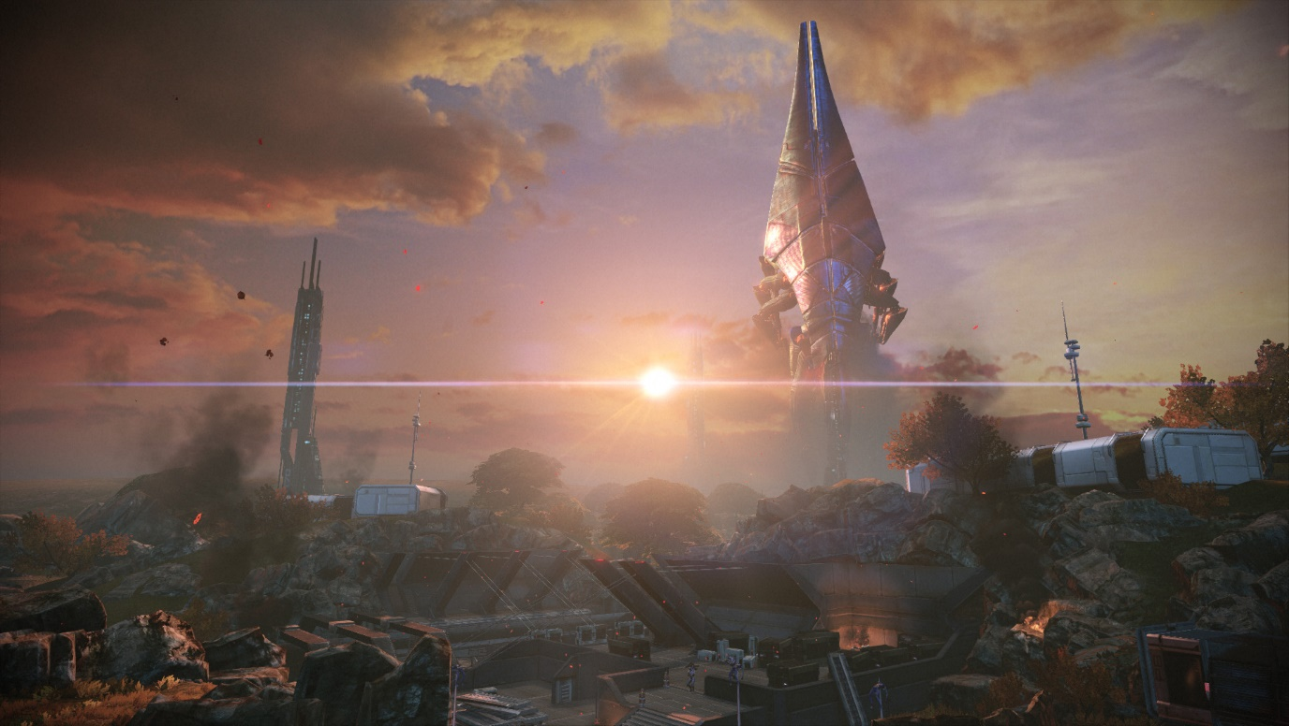The Mass Effect games all had several cinematic trailers which were just like very short movies to advertise the game when it was released. Most people haven’t seen them so I thought it would be good to have them all in one section that the user could look through and enjoy. The last page then is a shop page where the user can look through Mass Effect merchandise and add items to their cart. When they then try to checkout however there is a hidden joke that appears.

**User testing and feedback**

I tested my website with multiple new users to see what they thought about the website after going through it. They generally liked the design and layout of the website, with the shop being the most favoured page. The surprise at the checkout was always enjoyed by all the users. Some criticisms they had that they felt could be improved included:

* In the drop-down sections replace the circle button with an arrow indicator to show that it was a useable function on the website.
* Better positioning for the toggle GIFs button in the voice actor sections.
* Fix the bugs with the footers going all over the place.
* Making it more clear which pages are accessible and which are incomplete.

While I wasn’t able to find any big Mass Effect fans who could tell me how interesting the content was to them, I was able to get a good idea on what the experience of someone new to the series was like.

**Visual and Image editing techniques**

I used Photoshop to create all the edited images I have included on my website. These images include the three interactive buttons I have for each of the Mass Effect games at the bottom of my landing page. These were made using resized screenshots from the games and adding the logo to indicate which button to you to which game. I also made side by side edits for the voice actors so that people could easily see the real life faces behind the in-game characters.

The video that plays when you try to checkout and buy the items from the shop, I created myself using Premiere Pro, taking videos and music from the game then adding my own text which is a reference to the game over screen in Mass Effect.

**Additions and Enhancements**

**Trailers Page**

A new page I added was a trailers page for the Mass Effect games. Each of the Mass Effect games had great cinematic trailers that most people will have likely never seen. I thought having them all in one place would be a good idea and addition to the website.

* I split each of these trailers up into sections for each of the games.
* Each section has a button that can show and hide these sections.
* JavaScript is attached to the buttons that hides or shows the sections when they’re clicked.

**Shop Page**

A shop would be a good way for me to implement some JavaScript into my website. I added various items that can be purchases along with quantity and price values that then add up and can be purchased.

* Stylized shop page with everything in a flexible grid that adjusts with the screen.
* A quantity selector and a button to add the item to the cart afterwards.
* The item name, price and quantity stored in variables so everything can be properly output in a receipt and shopping cart.
* An output on the side of the screen that displays the item with the quantity being purchased and the cost for the items.
* A form will pop up when you check out for you to input your information into.
* Elements in the page that change when hovered over like buttons and images.

**Surprise Joke when you try to purchase items.**

With my website being based around Mass Effect, I wanted to include a joke somewhere that Mass Effect fans would find funny. This is triggered when you click the checkout button in the shop using JavaScript.

* There is a hidden video on the page that covers up the entire screen.
* When the checkout button is clicked, the video is shown and everything else on the screen is hidden.
* I made the video myself in Premiere Pro so that it would fit in well with everything, be the right file size and length.
* Once the video ends the page is refreshed.

**Feature to toggle GIFs on and off.**

I have GIFs placed throughout my website. They can be seen on the pages for the voice actors. These can get annoying if you are reading through the page and they replay themselves dozens of times. That is why I decided to add a button that allows you to toggle them on and off when clicked.

**Slideshow inside of the Mass Effect games section.**

I felt like the games section was very lifeless and uninteresting in my first version of the website due to me not knowing what else to add. I felt like a slideshow would be a good edition and thanks to a tutorial on W3Schools I was able to add one and modify the style code to fit in with my website.

* Fully functional slideshow with five different high-quality pictures and JavaScript.
* Inside a stylised box underneath the text at the bottom of the page.
* Arrows that allow you to move from one slide to another.
* Dots underneath that allows you to jump to a specific slide.

**Known Bugs and Issues List**

* I am not sure why but all .png files I tried to include in my website didn’t have transparent backgrounds like they should. They all had white backgrounds that looked bad, so I made the choice to remove them all entirely.
* Many of the links in my Navigation bar don’t take you anywhere as I designed my website as a concept for something bigger. I only have a couple page templates made but given more time, they can be used to flesh out the rest of the website.
* Resizing the website breaks a lot of the elements as I haven’t properly coded the classes.
* My Style sheets is excessive and can be optimized to be simpler while still working the same way.
* Issue with the toggle gif button that messes up the positioning on the footer of the page. The sticky positioning is also not working with it, so it is forced to be placed in an awkward position on the page that conflicts with other elements pushing them out of place.
* The footer does not work when I try inserting it into the shop page, it turns into a little box at the top and I don’t know why.
* Due to how I did the quantity selector in the shop, you can only pick a maximum of ten items at a time.

**References and Credits**

Jennifer Hale Image - Creator: Frederick M. Brown | Credit: Getty Images

Mark Meer Image - Photo by Peter Randolph

All game related images and videos copyright of EA and BioWare

Slideshow Tutorial - <https://www.w3schools.com/howto/howto_js_slideshow.asp>

Image Zoom on hover Tutorial - <https://w3bits.com/css-image-hover-zoom/>

I used a YouTube tutorial to help me with the code for the dropdown navigation bar - <https://www.youtube.com/watch?v=dmFC1e_CUAQ&t=330s>

Shop Items Used:

https://www.amazon.com/TUBBZ-Garrus-Vakarian-Collectible-Rubber/dp/B0CJYC9SXH

https://www.amazon.com/Dark-Horse-Deluxe-Effect-Alliance/dp/B08F813FML

https://www.amazon.com/X-COSTUME-Legendary-Cosplay-Halloween-Merchandise/dp/B095SJR6QW

https://gear.bioware.com/en-eu/products/mass-effect-archangel-dopp-bag

<https://gear.bioware.com/en-eu/products/mass-effect-blue-normandy-led-wall-art>